KNOWLEDGE INSTITUTE OF TECHNOLOGY
(An Autonomous Institution)
Department of Computer Science and Engineering
Mini Project Report
BE23CS315 – JAVA PROGRAMMING



Academic Year | 2025-2026 (Even)
Year / Sem / Section | II / IV / A
Project Title | E-Library System
Reg No | 611224104031
Name of the Student | Dharaneeshwaran K
Faculty Name | Mr. R. Sivaguru, AP/CSE
Signature

TABLE OF CONTENTS
S.No | Title | Page No
1 | Abstract | 1
2 | Introduction | 2
3 | System Analysis  3.1 Hardware Requirements  3.2 Software Requirements | 3
4 | Modules  4.1 Title of the modules  4.2 Description of modules | 4
5 | System Design  5.1 System Architecture | 5
6 | System Implementation | 7
7 | Screen Shots | 38
8 | Conclusion | 43
9 | References | 44

1. ABSTRACT
The Course Registration System is a software application designed to automate and streamline the process of course enrollment in educational institutions. This system provides an efficient and user-friendly platform where students can view available courses, register for subjects, and monitor their registration status. At the same time, administrators are given the ability to manage course information, review student requests, and approve or reject registrations with proper tracking.
The application is developed using Java, with JDBC for database connectivity and MySQL as the backend database. It ensures secure data handling through user authentication and maintains accurate records of students, courses, and registration details. The system also records timestamps such as registration date and approval time, which improves transparency and accountability in the process.
By replacing manual registration methods, the system significantly reduces paperwork, human errors, and processing time. It enhances efficiency by organizing data in a structured manner and allowing quick retrieval of information. The system is scalable and can be adapted to handle large numbers of users and courses.
Overall, the Course Registration System demonstrates the effective use of database-driven application development to solve real-world problems in academic management. It improves the overall experience for both students and administrators by providing a reliable, fast, and organized solution for course enrollment and management.
Keywords :
Course Registration System, Java, JDBC, MySQL, Student Management, Admin Control, Database System, Enrollment, Automation, Academic Management

2. INTRODUCTION
In modern educational institutions, managing course registration manually can be time-consuming, error-prone, and inefficient. With the increasing number of students and courses, there is a strong need for an automated system that can handle registration processes accurately and efficiently. The Course Registration System is developed to address these challenges by providing a digital platform for managing course enrollment activities.
This system allows students to easily browse available courses, register for their preferred subjects, and track the status of their applications. It eliminates the need for physical forms and reduces dependency on manual record-keeping. On the other hand, administrators can efficiently manage course details, monitor student registrations, and approve or reject requests based on availability and requirements. This ensures better control and organization within the academic environment.
The application is built using Java as the core programming language, JDBC for connecting and interacting with the database, and MySQL for storing and managing data. These technologies ensure reliability, security, and efficient handling of large volumes of information. The system also includes features like user authentication, structured data storage, and timestamp tracking to maintain transparency and accountability.
By implementing this system, institutions can significantly improve the speed and accuracy of the registration process. It reduces administrative workload and enhances the overall user experience for both students and staff. The Course Registration System thus serves as a practical solution for modernizing academic management and supporting digital transformation in education.
Objectives :
- To automate the course registration process
- To provide an easy interface for students
- To manage and store data efficiently
- To assist administrators in decision-making
- To improve accuracy and transparency
3. SYSTEM ANALYSIS
System Analysis is an important phase in the development of the Course Registration System. It involves studying the requirements of the system, understanding user needs, and identifying the resources required for implementation. This phase ensures that the system is developed efficiently with proper planning of hardware and software components.
3.1 Hardware Requirements :
Component | Specification
Processor | Intel Core i3 or above
RAM | 4 GB
Hard Disk | 500 GB or more
Monitor | Standard display (LED/LCD)
Input Devices | Keyboard and Mouse

3.2 Software Requirements :
Component | Details
Operating System | Windows 10 / Windows 11
Programming Language | Java
Database | MySQL Server 8.0
Connectivity Tool | JDBC (Java Database Connectivity)
IDE (Optional) | Eclipse / IntelliJ IDEA / NetBeans

The System Design of the Course Registration System defines its architecture and flow. It includes a user interface for students and admins, a database for storing course and student information, and a processing layer using Java and JDBC. It ensures efficient, secure, and organized handling of registrations.
4. MODULES
The Course Registration System is divided into several modules to organize functionality and simplify development. Each module handles a specific task within the system, ensuring clarity and easy maintenance.
4.1 Title of the modules :
- User Authentication Module
- Course Management Module
- Student Registration Module
- Admin Approval Module
- Registration History Module
4.2 Description of modules :
- User Authentication Module :
- Handles login and registration for both students and administrators. Ensures secure access with proper credentials.
- Course Management Module :
- Allows administrators to add, update, or remove courses. Maintains course details like ID, name, and available seats.
- Student Registration Module :
- Enables students to view available courses and register for their preferred subjects. Tracks registration requests in real time.
- Admin Approval Module :
- Allows administrators to review, approve, or reject student registration requests. Ensures proper allocation of courses and prevents conflicts.
- Registration History Module :
- Maintains records of all registrations, including status, submission time, and approval.

5. SYSTEM DESIGN
System design defines how the Course Registration System is structured to achieve efficient and reliable operation. It outlines the components, their interaction, and the flow of data between them.
5.1 System Architecture
The system follows a Three-Tier Architecture comprising:
- Presentation Layer (User Interface)
  - Provides interfaces for students and administrators.
  - Students can view courses, register, and check registration status.
  - Admins can manage courses, approve/reject registrations, and view history.
- Application Layer (Business Logic)
  - Processes all requests from the presentation layer.
  - Implements rules for registration, validation, and approval workflows.
  - Developed using Java, ensuring secure and efficient processing.
- Database Layer
  - Stores all student, course, and registration details.
  - Uses MySQL for structured data management.
  - Accessed via JDBC for queries, updates, and retrieval.
Flow of the System:
- Students log in → view courses → submit registration → data sent to business layer → admin approval → status updated in database → reflected back to student.

The Course Registration System follows a Three-tier architecture for efficient and secure operation. The Presentation Layer provides user interfaces for students and administrators to access courses, register, and manage approvals. The Application Layer implements business logic, handling registration rules, validation, and admin workflows using Java. The Database Layer stores all student, course, and registration information in MySQL, accessed through JDBC. Data flows from the user interface to the application layer, processed according to system rules, and updated in the database. This design ensures modularity, scalability, transparency, and reliable handling of all registration processes.
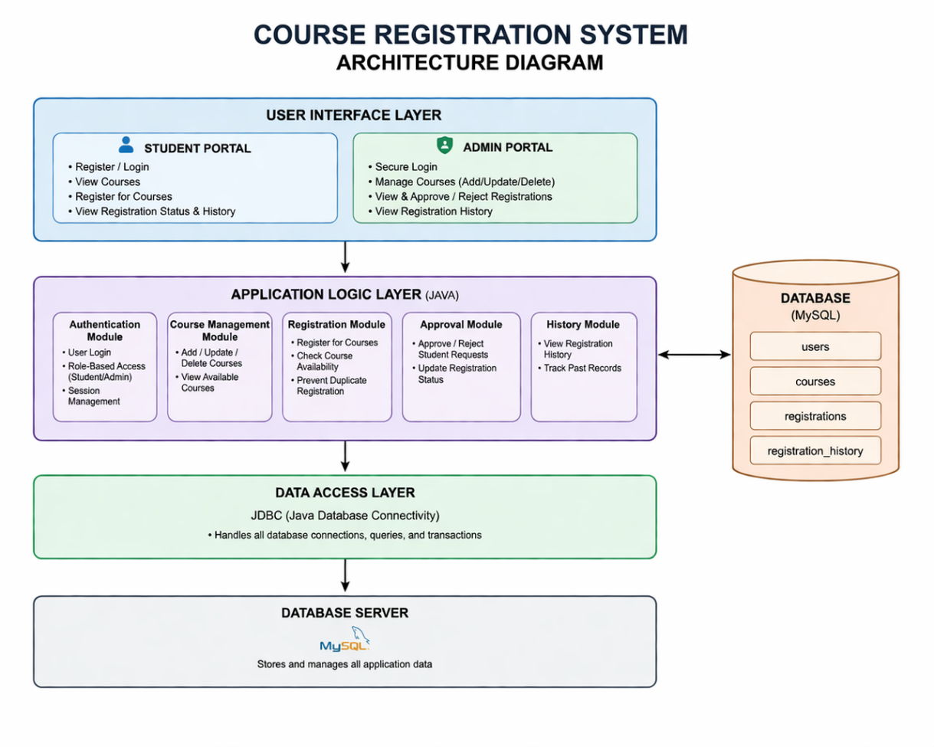
5.1 System Architecture Diagram

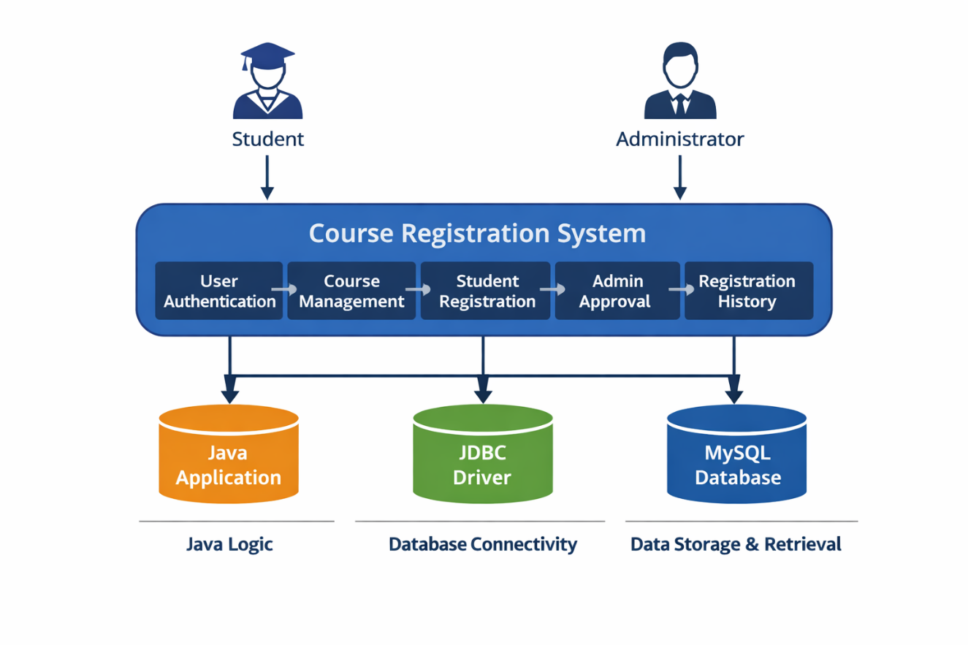
5.2 System Flow
6. SYSTEM IMPLEMENTATION
System Implementation is the phase where the Course Registration System is transformed from design into a functional software application. It involves writing code, setting up the database, integrating modules, and ensuring smooth operation. The system is developed using Java for programming, JDBC for database connectivity, and MySQL for storing all student, course, and registration information.
Java Source Code :
import java.sql.*;
import java.util.Scanner;
import java.io.Console;
import java.text.SimpleDateFormat;
import javax.mail.*;
import javax.mail.internet.*;
import java.util.Properties;

public class CourseSystemJDBC {
static Scanner sc = new Scanner(System.in);
public static void main(String[] args) {
Connection con = DBConnection.getConnection();
while (true) {
System.out.println("\n=====================================");
System.out.println(" COURSE REGISTRATION SYSTEM");
System.out.println("=====================================");
System.out.println("1. Student ");
System.out.println("2. Admin Login");
System.out.println("3. Exit");
System.out.println("=====================================");
System.out.print("Enter choice: ");
int choice = sc.nextInt();
sc.nextLine();
switch (choice) {
case 1 -> studentEntryMenu(con);
case 2 -> adminLogin(con);
case 3 -> {
System.out.println("Thank you for using the system!");
return;
}
default -> System.out.println("Invalid choice");
}
}
}
static void studentEntryMenu(Connection con) {
while (true) {
System.out.println("\n========= STUDENT PANEL =========");
System.out.println("1. Login");
System.out.println("2. Create New Account");
System.out.println("3. Forgot Password");
System.out.println("4. Back");
System.out.println("=================================");
System.out.print("Enter choice: ");
int ch = sc.nextInt();
sc.nextLine();
switch (ch) {
case 1 -> studentLoginOnly(con);
case 2 -> registerStudent(con);
case 3 -> {
System.out.print("Enter your Name: ");
String name = sc.nextLine();
forgotPassword(con, name);
}
case 4 -> { return; }
default -> System.out.println("Invalid choice");
}
}
}
static void studentLoginOnly(Connection con) {
try {
System.out.print("Enter Student Name: ");
String name = sc.nextLine();
String query = "SELECT * FROM students WHERE name=?";
PreparedStatement ps = con.prepareStatement(query);
ps.setString(1, name);
ResultSet rs = ps.executeQuery();
if (!rs.next()) {
System.out.println("User not found. Please create account.");
return;
}
int studentId = rs.getInt("id");
String dbPassword = rs.getString("password");
String email = rs.getString("email");
Console console = System.console();
String password;
if (console != null) {
char[] passArr = console.readPassword("Enter Password: ");
password = new String(passArr);
} else {
System.out.print("Enter Password: ");
password = sc.nextLine();
}
if (password.equals(dbPassword)) {
System.out.println("\nLogin Successful!");
System.out.println("Student Email: " + email);
studentMenu(con, studentId);
} else {
System.out.println("Incorrect Password.");
}
} catch (Exception e) {
System.out.println("Error: " + e.getMessage());
}
}
static void registerStudent(Connection con) {
try {
System.out.print("Enter Name: ");
String name = sc.nextLine();
// check if already exists
String check = "SELECT * FROM students WHERE name=?";
PreparedStatement psCheck = con.prepareStatement(check);
psCheck.setString(1, name);
ResultSet rs = psCheck.executeQuery();
if (rs.next()) {
System.out.println("User already exists. Try login.");
return;
}
String email;
while (true) {
System.out.print("Enter Email: ");
email = sc.nextLine();
if (email.contains("@") && email.contains(".")) break;
System.out.println("Invalid email.");
}
Console console = System.console();
String password;
while (true) {
if (console != null) {
char[] passArr = console.readPassword("Create 4-digit Password: ");
password = new String(passArr);
} else {
System.out.print("Create 4-digit Password: ");
password = sc.nextLine();
}
if (password.length() == 4) break;
System.out.println("Password must be 4 digits.");
}
String insert = "INSERT INTO students(name,email,password) VALUES(?,?,?)";
PreparedStatement ps = con.prepareStatement(insert);
ps.setString(1, name);
ps.setString(2, email);
ps.setString(3, password);
ps.executeUpdate();
System.out.println("Account created successfully!");
} catch (Exception e) {
System.out.println("Error: " + e.getMessage());
}
}
static void forgotPassword(Connection con, String name) {
try {
Console console = System.console();
String newPass;
System.out.println("+----------------------------------+");
System.out.println("| PASSWORD RESET |");
System.out.println("+----------------------------------+");
while (true) {
if (console != null) {
char[] passArr = console.readPassword("Enter New 4-digit Password: ");
newPass = new String(passArr);
} else {
System.out.print("Enter New 4-digit Password: ");
newPass = sc.nextLine();
}
if (newPass.length() == 4) break;
System.out.println("Password must be exactly 4 characters.");
}
String update = "UPDATE students SET password=? WHERE name=?";
PreparedStatement ps = con.prepareStatement(update);
ps.setString(1, newPass);
ps.setString(2, name);
ps.executeUpdate();
System.out.println("\nPassword updated successfully!");
} catch (Exception e) {
System.out.println("Error: " + e.getMessage());
}
}
// STUDENT MENU
static void studentMenu(Connection con, int studentId) {
while (true) {
System.out.println("\n----------- STUDENT MENU -----------");
System.out.println("1. View Courses");
System.out.println("2. Register Course");
System.out.println("3. View Registered Courses");
System.out.println("4. Drop Course");
System.out.println("5. Search Course");
System.out.println("6. Registration History");
System.out.println("7. Logout");
System.out.println("------------------------------------");
System.out.print("Enter choice: ");
int ch = sc.nextInt();
switch (ch) {
case 1 -> viewCourses(con);
case 2 -> registerCourse(con, studentId);
case 3 -> viewRegisteredCourses(con, studentId);
case 4 -> dropCourse(con, studentId);
case 5 -> searchCourse(con);
case 6 -> registrationHistory(con, studentId);
case 7 -> { return; }
default -> System.out.println("Invalid choice");
}
}
}
// VIEW COURSES
static void viewCourses(Connection con) {
try {
String query =
"SELECT c.course_id,c.course_name,c.total_seats," +
"(c.total_seats - COUNT(r.course_id)) AS seats_left " +
"FROM courses c LEFT JOIN registrations r " +
"ON c.course_id=r.course_id " +
"GROUP BY c.course_id";
Statement st = con.createStatement();
ResultSet rs = st.executeQuery(query);
System.out.println("+------------+----------------------+-------------+-------------+------------+");
System.out.println("| Course ID | Course Name | Total Seats | Seats Left | Status |");
System.out.println("+------------+----------------------+-------------+-------------+------------+");
while (rs.next()) {
int seatsLeft = rs.getInt("seats_left");
String status = seatsLeft == 0 ? "FULL" : "AVAILABLE";
System.out.printf("| %-10d | %-20s | %-11d | %-11d | %-10s |\n",
rs.getInt("course_id"),
rs.getString("course_name"),
rs.getInt("total_seats"),
seatsLeft,
status);
}
System.out.println("+------------+----------------------+-------------+-------------+------------+");
} catch (Exception e) {
System.out.println("Error: " + e.getMessage());
}
}
// REGISTER COURSE
static void registerCourse(Connection con, int studentId) {
viewCourses(con);
System.out.print("Enter Course ID: ");
int cid = sc.nextInt();
try {
// Check course exists
String courseCheck = "SELECT * FROM courses WHERE course_id=?";
PreparedStatement ps1 = con.prepareStatement(courseCheck);
ps1.setInt(1, cid);
ResultSet courseRs = ps1.executeQuery();
if (!courseRs.next()) {
System.out.println("Invalid Course ID.");
return;
}
// Check duplicate
String dup = "SELECT * FROM registrations WHERE student_id=? AND course_id=?";
PreparedStatement ps2 = con.prepareStatement(dup);
ps2.setInt(1, studentId);
ps2.setInt(2, cid);
ResultSet dupRs = ps2.executeQuery();
if (dupRs.next()) {
System.out.println("You already registered for this course.");
return;
}
// Check seats
String seatQuery =
"SELECT total_seats - COUNT(r.course_id) AS seats_left " +
"FROM courses c LEFT JOIN registrations r " +
"ON c.course_id=r.course_id WHERE c.course_id=?";
PreparedStatement ps3 = con.prepareStatement(seatQuery);
ps3.setInt(1, cid);
ResultSet seatRs = ps3.executeQuery();
if (seatRs.next() && seatRs.getInt("seats_left") <= 0) {
System.out.println("Course Full.");
return;
}
// Insert registration
String query = "INSERT INTO registrations(student_id, course_id, status) VALUES(?, ?, 'PENDING')";
PreparedStatement ps = con.prepareStatement(query);
ps.setInt(1, studentId);
ps.setInt(2, cid);
ps.executeUpdate();
System.out.println("Registration request sent to Admin for approval.");
} catch (Exception e) {
System.out.println("Error: " + e.getMessage());
}
}
static void viewRegisteredCourses(Connection con, int studentId) {
try {
String query =
"SELECT c.course_id, c.course_name " +
"FROM courses c JOIN registrations r " +
"ON c.course_id = r.course_id " +
"WHERE r.student_id = ? AND r.status = 'APPROVED'";
PreparedStatement ps = con.prepareStatement(query);
ps.setInt(1, studentId);
ResultSet rs = ps.executeQuery();
boolean found = false;
System.out.println("+------------+----------------------------+");
System.out.println("| Course ID | Course Name |");
System.out.println("+------------+----------------------------+");
while (rs.next()) {
found = true;
System.out.printf("| %-10d | %-26s |\n",
rs.getInt("course_id"),
rs.getString("course_name"));
}
if (!found) {
System.out.printf("| %-10s | %-26s |\n", "-", "No Approved Courses");
}
System.out.println("+------------+----------------------------+");
} catch (Exception e) {
System.out.println("Error: " + e.getMessage());
}
}
static void dropCourse(Connection con, int studentId) {
System.out.print("Enter Course ID to Drop: ");
int cid = sc.nextInt();
try {
// Only allow dropping APPROVED courses
String query = "DELETE FROM registrations WHERE student_id=? AND course_id=? AND status='APPROVED'";
PreparedStatement ps = con.prepareStatement(query);
ps.setInt(1, studentId);
ps.setInt(2, cid);
int rows = ps.executeUpdate();
if (rows > 0) {
System.out.println("Course Dropped Successfully!");
} else {
System.out.println("-- Cannot drop this course. Either not registered or pending approval --");
}
} catch (Exception e) {
System.out.println("Error: " + e.getMessage());
}
}
// SEARCH COURSE
static void searchCourse(Connection con) {
try {
sc.nextLine();
System.out.print("Enter Course Name: ");
String name = sc.nextLine();
String query =
"SELECT c.course_id, c.course_name, c.total_seats, " +
"(c.total_seats - COUNT(r.course_id)) AS seats_left " +
"FROM courses c LEFT JOIN registrations r " +
"ON c.course_id = r.course_id " +
"WHERE c.course_name LIKE ? " +
"GROUP BY c.course_id";
PreparedStatement ps = con.prepareStatement(query);
ps.setString(1, "%" + name + "%");
ResultSet rs = ps.executeQuery();
boolean found = false;
System.out.println("+------------+----------------------+-------------+-------------+");
System.out.println("| Course ID | Course Name | Total Seats | Seats Left |");
System.out.println("+------------+----------------------+-------------+-------------+");
while (rs.next()) {
found = true;
System.out.printf("| %-10d | %-20s | %-11d | %-11d |\n",
rs.getInt("course_id"),
rs.getString("course_name"),
rs.getInt("total_seats"),
rs.getInt("seats_left"));
}
if (!found) {
System.out.printf("| %-10s | %-20s | %-11s | %-11s |\n",
"-", "Course Not Found", "-", "-");
}
System.out.println("+------------+----------------------+-------------+-------------+");
} catch (Exception e) {
System.out.println("Error: " + e.getMessage());
}
}

// =============================
// REGISTRATION HISTORY (STUDENT) - Clean Table Format with Admin Approval
// =============================
static void registrationHistory(Connection con, int studentId) {
try {
// Column widths
int idWidth = 10;
int nameWidth = 25;
int statusWidth = 10;
int requestedWidth = 20;
int approvedWidth = 20;
// Separator line
String line = "+"
+ "-".repeat(idWidth + 2) + "+"
+ "-".repeat(nameWidth + 2) + "+"
+ "-".repeat(statusWidth + 2) + "+"
+ "-".repeat(requestedWidth + 2) + "+"
+ "-".repeat(approvedWidth + 2) + "+";
System.out.println(line);
System.out.printf("| %-10s | %-25s | %-10s | %-20s | %-20s |\n",
"Course ID", "Course Name", "Status", "Requested On", "Approved On");
System.out.println(line);
String query =
"SELECT c.course_id, c.course_name, r.status, r.created_at, r.approved_at " +
"FROM registrations r " +
"JOIN courses c ON r.course_id = c.course_id " +
"WHERE r.student_id=? " +
"ORDER BY r.created_at DESC";
PreparedStatement ps = con.prepareStatement(query);
ps.setInt(1, studentId);
ResultSet rs = ps.executeQuery();
boolean found = false;
SimpleDateFormat sdf = new SimpleDateFormat("yyyy-MM-dd HH:mm:ss");
while (rs.next()) {
found = true;
int cid = rs.getInt("course_id");
String cname = rs.getString("course_name");
String status = rs.getString("status");
Timestamp requested = rs.getTimestamp("created_at");
Timestamp approved = rs.getTimestamp("approved_at");
String requestedStr = (requested != null) ? sdf.format(requested) : "-";
String approvedStr = (approved != null) ? sdf.format(approved) : "-";
// Truncate long course names
if (cname.length() > nameWidth) cname = cname.substring(0, nameWidth - 3) + "...";
System.out.printf("| %-10d | %-25s | %-10s | %-20s | %-20s |\n",
cid, cname, status, requestedStr, approvedStr);
}
if (!found) {
System.out.printf("| %-10s | %-25s | %-10s | %-20s | %-20s |\n",
"-", "No registration history", "-", "-", "-");
}
System.out.println(line);
} catch (Exception e) {
System.out.println("Error: " + e.getMessage());
}
}
// ADMIN LOGIN WITH HIDDEN PASSWORD
static void adminLogin(Connection con) {
try {
System.out.print("Enter Admin Username: ");
String user = sc.nextLine().trim();
if (user.isEmpty()) {
System.out.println("Username cannot be empty!");
return;
}
String pass;
Console console = System.console();
if (console != null) {
char[] passwordArray = console.readPassword("Enter Admin Password: ");
pass = new String(passwordArray);
} else {
// fallback if console not supported (IDE)
pass = readPassword("Enter Admin Password: ");
}
if (pass.isEmpty()) {
System.out.println("Password cannot be empty!");
return;
}
// DATABASE CHECK (instead of hardcoded)
String query = "SELECT * FROM admins WHERE username=? AND password=?";
PreparedStatement ps = con.prepareStatement(query);
ps.setString(1, user);
ps.setString(2, pass);
ResultSet rs = ps.executeQuery();
if (rs.next()) {
System.out.println("\nLogin Successful !!!");
adminMenu(con);
} else {
System.out.println("\nInvalid credentials.");
}
} catch (Exception e) {
System.out.println("Error: " + e.getMessage());
}
}
// ADMIN MENU
static void adminMenu(Connection con) {
while (true) {
System.out.println("----------- ADMIN MENU -----------");
System.out.println("1. View Courses");
System.out.println("2. Add Course");
System.out.println("3. Delete Course");
System.out.println("4. Dashboard");
System.out.println("5. View Students Per Course");
System.out.println("6. Approve Registrations");
System.out.println("7. Search Course");
System.out.println("8. View All Students");
System.out.println("9. Create New Admin");
System.out.println("10. Exit");
System.out.println("----------------------------------");
System.out.print("Enter choice: ");
int ch = sc.nextInt();
switch(ch) {
case 1 -> viewCourses(con);
case 2 -> addCourse(con);
case 3 -> deleteCourse(con);
case 4 -> dashboard(con);
case 5 -> studentsPerCourse(con);
case 6 -> approveRegistrations(con);
case 7 -> searchCourse1(con); // Admin search option
case 8 -> viewAllStudents(con);
case 9 -> createStaff(con);
case 10 -> { return; }
default -> System.out.println("Invalid choice");
}
}
}
// ADD COURSE
static void addCourse(Connection con) {
try {
System.out.print("Enter Course ID: ");
int id = sc.nextInt();
sc.nextLine();
System.out.print("Enter Course Name: ");
String name = sc.nextLine();
System.out.print("Enter Total Seats: ");
int seats = sc.nextInt();
String query = "INSERT INTO courses VALUES(?,?,?)";
PreparedStatement ps = con.prepareStatement(query);
ps.setInt(1, id);
ps.setString(2, name);
ps.setInt(3, seats);
ps.executeUpdate();
System.out.println("Course Added Successfully!");
} catch (Exception e) {
System.out.println(e.getMessage());
}
}
// DELETE COURSE
static void deleteCourse(Connection con) {
try {
System.out.print("Enter Course ID to delete: ");
int id = sc.nextInt();
String query = "DELETE FROM courses WHERE course_id=?";
PreparedStatement ps = con.prepareStatement(query);
ps.setInt(1, id);
ps.executeUpdate();
System.out.println("Course Deleted Successfully!");
} catch (Exception e) {
System.out.println(e.getMessage());
}
}
// DASHBOARD (Admin) - counts only APPROVED registrations
static void dashboard(Connection con) {
try {
Statement st = con.createStatement();
// Total Students
ResultSet rs = st.executeQuery("SELECT COUNT(*) FROM students");
rs.next();
int students = rs.getInt(1);
// Total Courses
rs = st.executeQuery("SELECT COUNT(*) FROM courses");
rs.next();
int courses = rs.getInt(1);
// Total Registrations (only APPROVED)
rs = st.executeQuery("SELECT COUNT(*) FROM registrations WHERE status='APPROVED'");
rs.next();
int registrations = rs.getInt(1);
System.out.println("\n+----------------------+----------------+");
System.out.println("| Metric | Count |");
System.out.println("+----------------------+----------------+");
System.out.printf("| %-20s | %-14d |\n", "Total Students", students);
System.out.printf("| %-20s | %-14d |\n", "Total Courses", courses);
System.out.printf("| %-20s | %-14d |\n", "Total Registrations", registrations);
System.out.println("+----------------------+----------------+");
// Top 3 courses based on APPROVED registrations only
String topQuery =
"SELECT c.course_name, COUNT(r.course_id) AS students " +
"FROM courses c LEFT JOIN registrations r " +
"ON c.course_id = r.course_id AND r.status='APPROVED' " + // only APPROVED
"GROUP BY c.course_id ORDER BY students DESC LIMIT 3";
rs = st.executeQuery(topQuery);
System.out.println("\nTop 3 Popular Courses");
System.out.println("+----------------------+----------------+");
System.out.println("| Course Name | Students |");
System.out.println("+----------------------+----------------+");
while(rs.next()){
System.out.printf("| %-20s | %-14d |\n",
rs.getString("course_name"),
rs.getInt("students"));
}
System.out.println("+----------------------+----------------+");
} catch(Exception e){
System.out.println("Error: " + e.getMessage());
}
}
static void studentsPerCourse(Connection con) {
try {
String courseQuery = "SELECT course_id, course_name FROM courses";
Statement courseStmt = con.createStatement();
ResultSet courses = courseStmt.executeQuery(courseQuery);
while (courses.next()) {
int courseId = courses.getInt("course_id");
String courseName = courses.getString("course_name");
System.out.println("\nCourse ID: " + courseId + " | Course Name: " + courseName);
System.out.println("+------------+----------------------+");
System.out.println("| Student ID | Student Name |");
System.out.println("+------------+----------------------+");
// Only show approved students
String studentQuery =
"SELECT s.id, s.name FROM registrations r " +
"JOIN students s ON r.student_id = s.id " +
"WHERE r.course_id = ? AND r.status = 'APPROVED'";
PreparedStatement ps = con.prepareStatement(studentQuery);
ps.setInt(1, courseId);
ResultSet rs = ps.executeQuery();
boolean found = false;
while (rs.next()) {
found = true;
System.out.printf("| %-10d | %-20s |\n",
rs.getInt("id"),
rs.getString("name"));
}
if (!found) {
System.out.printf("| %-10s | %-20s |\n", "-", "No Students");
}
System.out.println("+------------+----------------------+");
}
} catch (Exception e) {
System.out.println("Error: " + e.getMessage());
}
}
// APPROVE REGISTRATIONS (Admin) - with Email Integration
static void approveRegistrations(Connection con) {
try {
// Fetch all pending registrations
String query =
"SELECT r.student_id, s.name AS student_name, s.email, " +
"c.course_id, c.course_name " +
"FROM registrations r " +
"JOIN students s ON r.student_id = s.id " +
"JOIN courses c ON r.course_id = c.course_id " +
"WHERE r.status='PENDING'";
PreparedStatement ps = con.prepareStatement(query);
ResultSet rs = ps.executeQuery();
System.out.println("+------------+----------------------+------------+------------------------+");
System.out.println("| Student ID | Student Name | Course ID | Course Name |");
System.out.println("+------------+----------------------+------------+------------------------+");
boolean found = false;
while(rs.next()){
found = true;
int sid = rs.getInt("student_id");
String sname = rs.getString("student_name");
int cid = rs.getInt("course_id");
String cname = rs.getString("course_name");
System.out.printf("| %-10d | %-20s | %-10d | %-22s |\n",
sid, sname, cid, cname);
}
if(!found){
System.out.printf("| %-10s | %-20s | %-10s | %-22s |\n",
"-", "No Pending Requests", "-", "-");
}
System.out.println("+------------+----------------------+------------+------------------------+");
// Only ask if pending exists
if(found){
System.out.print("Enter Student ID to approve: ");
int sid = sc.nextInt();
System.out.print("Enter Course ID to approve: ");
int cid = sc.nextInt();
sc.nextLine(); // buffer fix
// Get student email + details
String fetchDetails =
"SELECT s.name, s.email, c.course_name " +
"FROM registrations r " +
"JOIN students s ON r.student_id = s.id " +
"JOIN courses c ON r.course_id = c.course_id " +
"WHERE r.student_id=? AND r.course_id=?";
PreparedStatement psFetch = con.prepareStatement(fetchDetails);
psFetch.setInt(1, sid);
psFetch.setInt(2, cid);
ResultSet rs2 = psFetch.executeQuery();
if(!rs2.next()){
System.out.println("Invalid selection.");
return;
}
String studentName = rs2.getString("name");
String email = rs2.getString("email");
String courseName = rs2.getString("course_name");
// Update status
String approveQuery =
"UPDATE registrations " +
"SET status='APPROVED', approved_at=CURRENT_TIMESTAMP " +
"WHERE student_id=? AND course_id=? AND status='PENDING'";
PreparedStatement ps2 = con.prepareStatement(approveQuery);
ps2.setInt(1, sid);
ps2.setInt(2, cid);
int updated = ps2.executeUpdate();
if(updated > 0){
System.out.println("Registration Approved Successfully!");
// Send Email
sendEmail(email, studentName, courseName, "APPROVED");
} else {
System.out.println("Request not found or already approved.");
}
}
} catch(Exception e){
System.out.println("Error: " + e.getMessage());
}
}
static void sendEmail(String toEmail, String studentName, String courseName, String status) {
final String fromEmail = "mathanpmk2007@gmail.com";
final String password = "sgovxfgdqdvypxha";
Properties props = new Properties();
props.put("mail.smtp.auth", "true");
props.put("mail.smtp.starttls.enable", "true");
props.put("mail.smtp.host", "smtp.gmail.com");
props.put("mail.smtp.port", "587");
props.put("mail.smtp.ssl.trust", "smtp.gmail.com");
props.put("mail.smtp.ssl.protocols", "TLSv1.2");
System.setProperty("https.protocols", "TLSv1.2");
Session session = Session.getInstance(props,
new Authenticator() {
protected PasswordAuthentication getPasswordAuthentication() {
return new PasswordAuthentication(fromEmail, password);
}
});
try {
Message message = new MimeMessage(session);
message.setFrom(new InternetAddress(fromEmail));
message.setRecipients(Message.RecipientType.TO,
InternetAddress.parse(toEmail));
session.setDebug(true);
String subject = "Course Registration " + status + " Notification";
message.setSubject(subject);
String msg;
if(status.equals("APPROVED")) {
msg = "Hello " + studentName + ",\n\n"
+ "Congratulations !!!\n"
+ "Your registration for the course \"" + courseName + "\" has been APPROVED.\n\n"
+ "You can now attend the course.\n\n"
+ "Approved Time: " + java.time.LocalDateTime.now() + "\n\n"
+ "Best Regards,\nCourse Management Team";
} else {
msg = "Hello " + studentName + ",\n\n"
+ "We regret to inform you that your registration for the course \"" + courseName + "\" has been REJECTED.\n\n"
+ "Please contact admin for more details.\n\n"
+ "Checked Time: " + java.time.LocalDateTime.now() + "\n\n"
+ "Regards,\nCourse Management Team";
}
message.setText(msg);
Transport.send(message);
System.out.println("📧 Email sent successfully!");
} catch (Exception e) {
System.out.println("Email failed: " + e.getMessage());
}
}
// SEARCH COURSE (Admin) - properly aligned
static void searchCourse1(Connection con) {
try {
sc.nextLine();
System.out.print("Enter Course Name to search: ");
String name = sc.nextLine();
String query = "SELECT c.course_id, c.course_name, c.total_seats, " +
"(c.total_seats - COUNT(r.course_id)) AS seats_left, " +
"COUNT(r.student_id) AS registered " +
"FROM courses c LEFT JOIN registrations r " +
"ON c.course_id = r.course_id " +
"WHERE c.course_name LIKE ? " +
"GROUP BY c.course_id";
PreparedStatement ps = con.prepareStatement(query);
ps.setString(1, "%" + name + "%");
ResultSet rs = ps.executeQuery();
System.out.println("+------------+----------------------+-------------+-------------+------------+");
System.out.println("| Course ID | Course Name | Total Seats | Seats Left | Registered |");
System.out.println("+------------+----------------------+-------------+-------------+------------+");
boolean found = false;
while(rs.next()){
found = true;
System.out.printf("| %-10d | %-20s | %-11d | %-11d | %-10d |\n",
rs.getInt("course_id"),
rs.getString("course_name"),
rs.getInt("total_seats"),
rs.getInt("seats_left"),
rs.getInt("registered"));
}
if(!found){
System.out.printf("| %-10s | %-20s | %-11s | %-11s | %-10s |\n",
"-", "No course found", "-", "-", "-");
}
System.out.println("+------------+----------------------+-------------+-------------+------------+");
} catch(Exception e){
System.out.println("Error: " + e.getMessage());
}
}
// =============================
// VIEW STUDENT DETAILS (Admin) - Properly Aligned
// =============================
static void viewAllStudents(Connection con) {
try {
// Fetch all students
String studentQuery = "SELECT id, name, email FROM students";
Statement st = con.createStatement();
ResultSet students = st.executeQuery(studentQuery);
// Define column widths
int idWidth = 10;
int nameWidth = 25;
int emailWidth = 30;
int courseWidth = 40;
String line = "+" + "-".repeat(idWidth + 2)
+ "+" + "-".repeat(nameWidth + 2)
+ "+" + "-".repeat(emailWidth + 2)
+ "+" + "-".repeat(courseWidth + 2) + "+";
// Table header
System.out.println(line);
System.out.printf("| %-10s | %-25s | %-30s | %-40s |\n",
"Student ID", "Student Name", "Email", "Registered Courses");
System.out.println(line);
boolean foundStudent = false;
while (students.next()) {
foundStudent = true;
int studentId = students.getInt("id");
String name = students.getString("name");
String email = students.getString("email");
// Fetch courses registered and approved for this student
String courseQuery =
"SELECT c.course_name " +
"FROM registrations r " +
"JOIN courses c ON r.course_id = c.course_id " +
"WHERE r.student_id=? AND r.status='APPROVED'";
PreparedStatement ps = con.prepareStatement(courseQuery);
ps.setInt(1, studentId);
ResultSet courses = ps.executeQuery();
StringBuilder courseList = new StringBuilder();
while (courses.next()) {
if (courseList.length() > 0) courseList.append(", ");
courseList.append(courses.getString("course_name"));
}
String registeredCourses = courseList.length() > 0 ? courseList.toString() : "None";
// Truncate if too long to fit column
name = name.length() > nameWidth ? name.substring(0, nameWidth - 3) + "..." : name;
email = email.length() > emailWidth ? email.substring(0, emailWidth - 3) + "..." : email;
registeredCourses = registeredCourses.length() > courseWidth ? registeredCourses.substring(0, courseWidth - 3) + "..." : registeredCourses;
System.out.printf("| %-10d | %-25s | %-30s | %-40s |\n",
studentId, name, email, registeredCourses);
}
if (!foundStudent) {
System.out.printf("| %-10s | %-25s | %-30s | %-40s |\n",
"-", "No Students Found", "-", "-");
}
System.out.println(line);
} catch (Exception e) {
System.out.println("Error: " + e.getMessage());
}
}
static void createStaff(Connection con) {
try {
sc.nextLine(); //FIX buffer issue
System.out.print("Enter New Staff Username: ");
String username = sc.nextLine().trim();
if (username.isEmpty()) {
System.out.println("Username cannot be empty!");
return;
}
// check already exists
String check = "SELECT * FROM admins WHERE username=?";
PreparedStatement psCheck = con.prepareStatement(check);
psCheck.setString(1, username);
ResultSet rs = psCheck.executeQuery();
if (rs.next()) {
System.out.println("Username already exists!");
return;
}
// Use reusable password method (best practice)
String password = readPassword("Enter Password: ");
if (password.isEmpty()) {
System.out.println("Password cannot be empty!");
return;
}
String insert = "INSERT INTO admins(username, password) VALUES(?,?)";
PreparedStatement ps = con.prepareStatement(insert);
ps.setString(1, username);
ps.setString(2, password);
int rows = ps.executeUpdate();
if (rows > 0) {
System.out.println("New Staff Created Successfully!");
} else {
System.out.println("Failed to create staff.");
}
} catch (Exception e) {
System.out.println("Error: " + e.getMessage());
}
}
static String readPassword(String prompt) {
Console console = System.console();
if (console != null) {
char[] passArr = console.readPassword(prompt);
return new String(passArr);
} else {
// Fallback (IDE will show password)
System.out.print(prompt);
return sc.nextLine();
}
}
}
7. SCREENSHOTS
The following section describes the key screens of the Course Registration System :

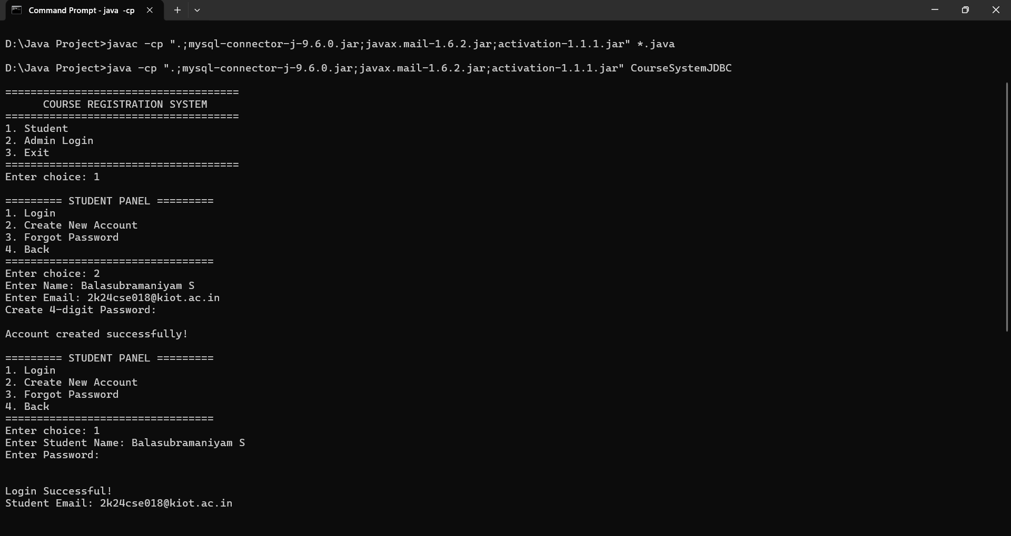
7.1 Main Login Page & Student’s SignUp Page

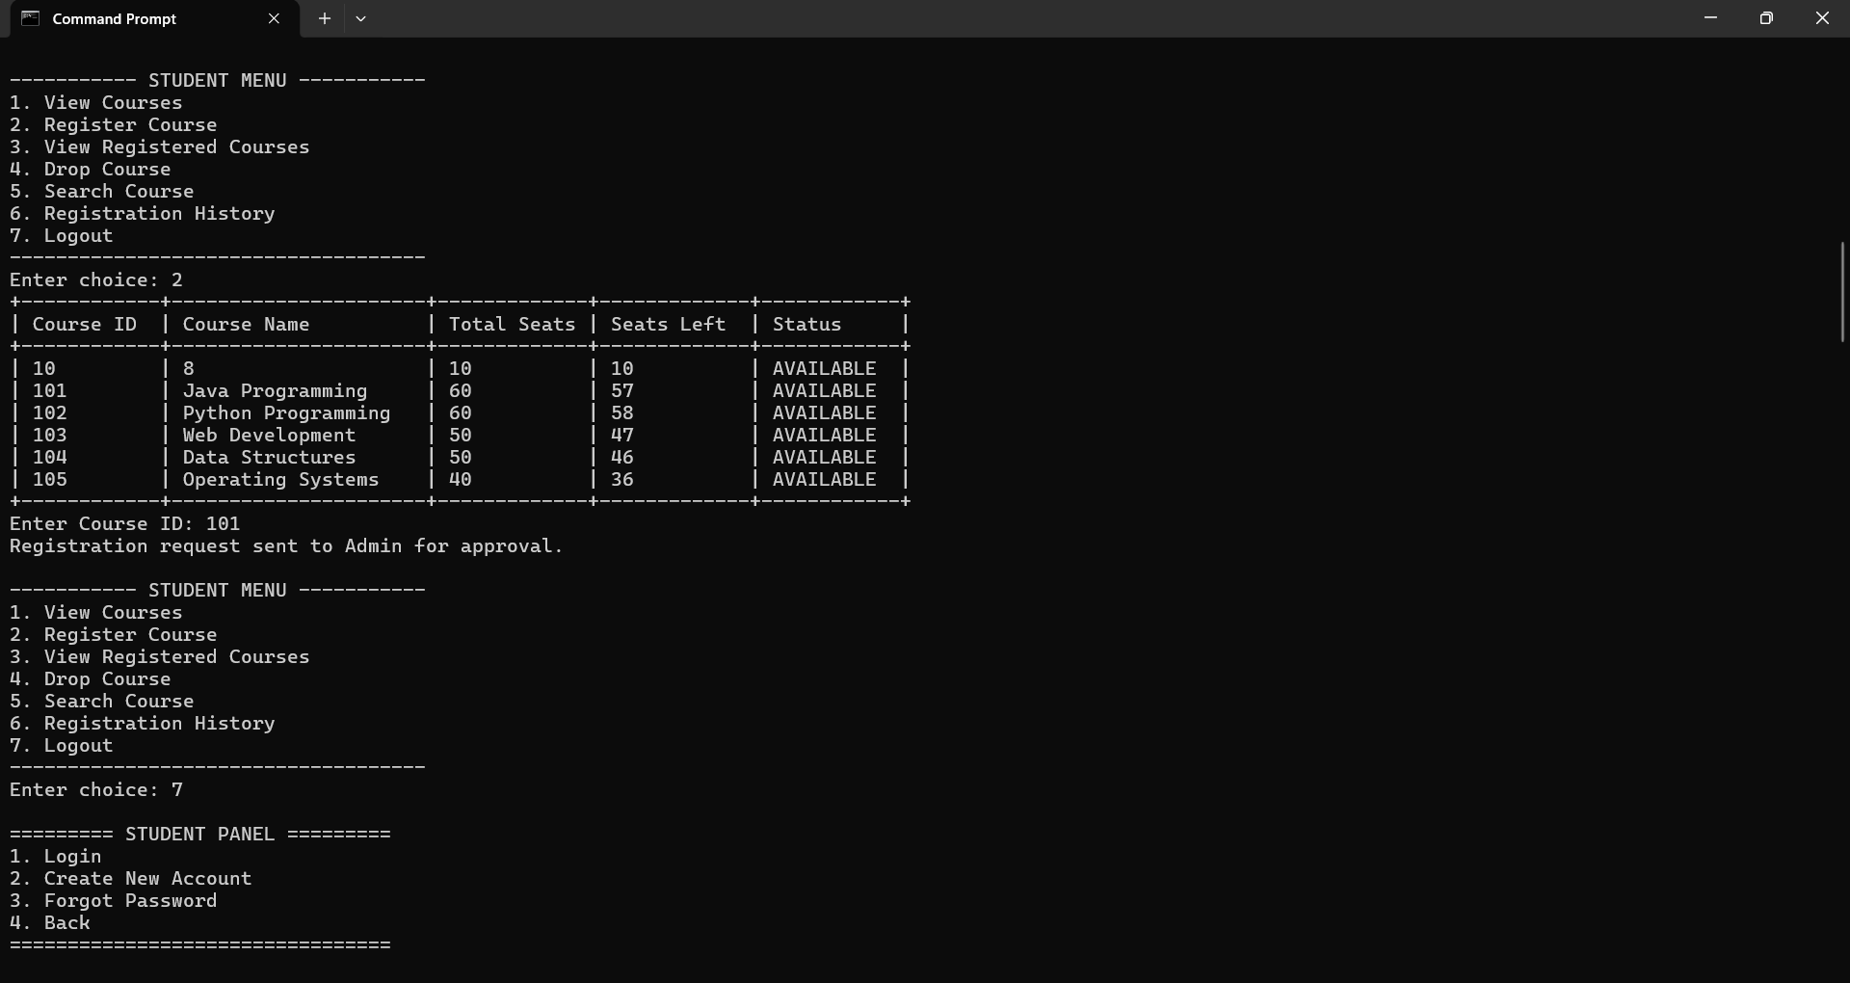
7.2 Student’s Menu Page & Course Registration

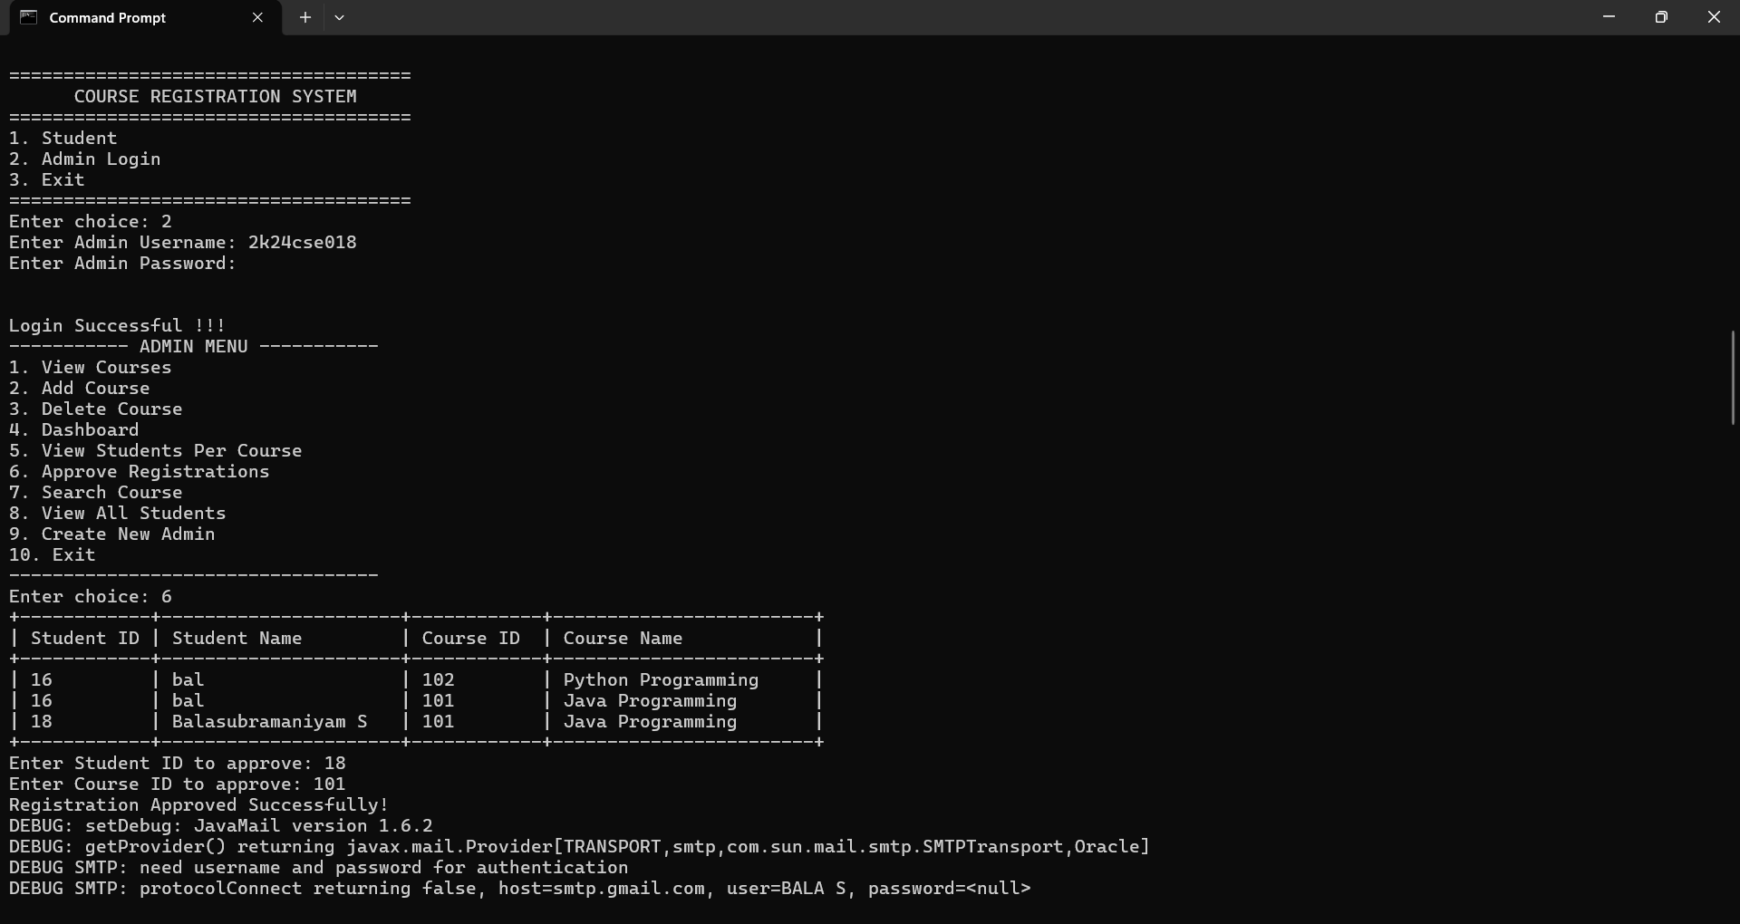
7.3 Admin’s Login Page, Admin Menu & Course Approval

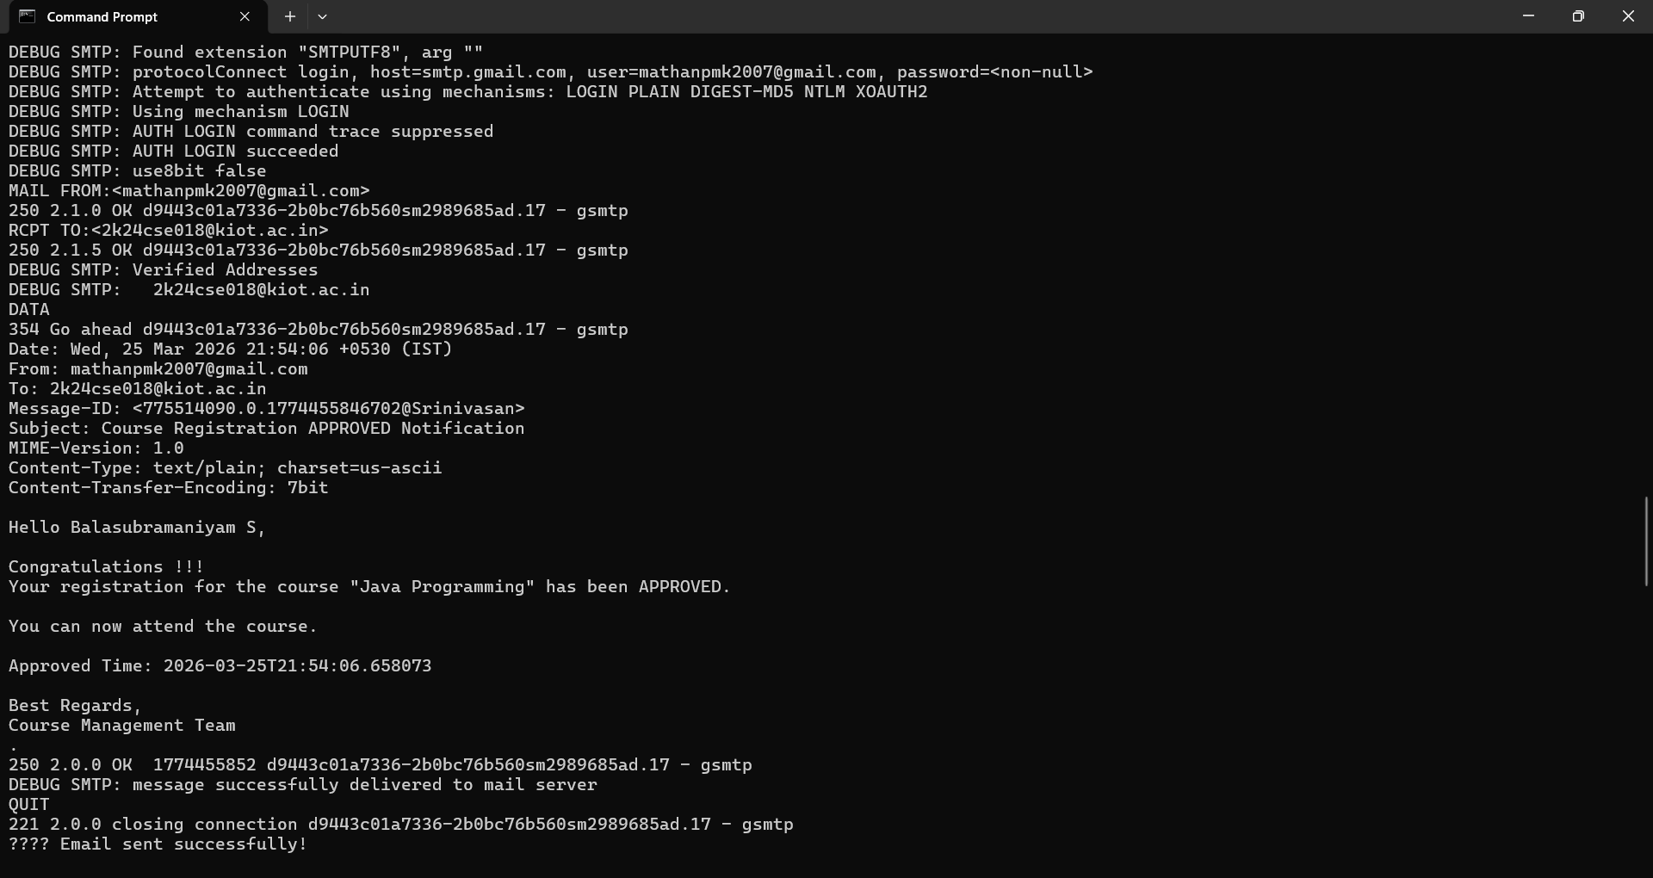
7.4 Email Send to Approved Students

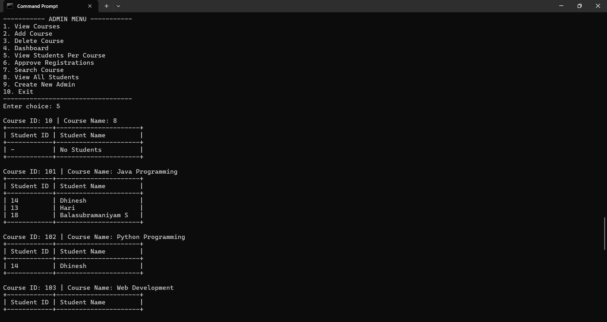
7.5 View Students Per Course in Admin Menu

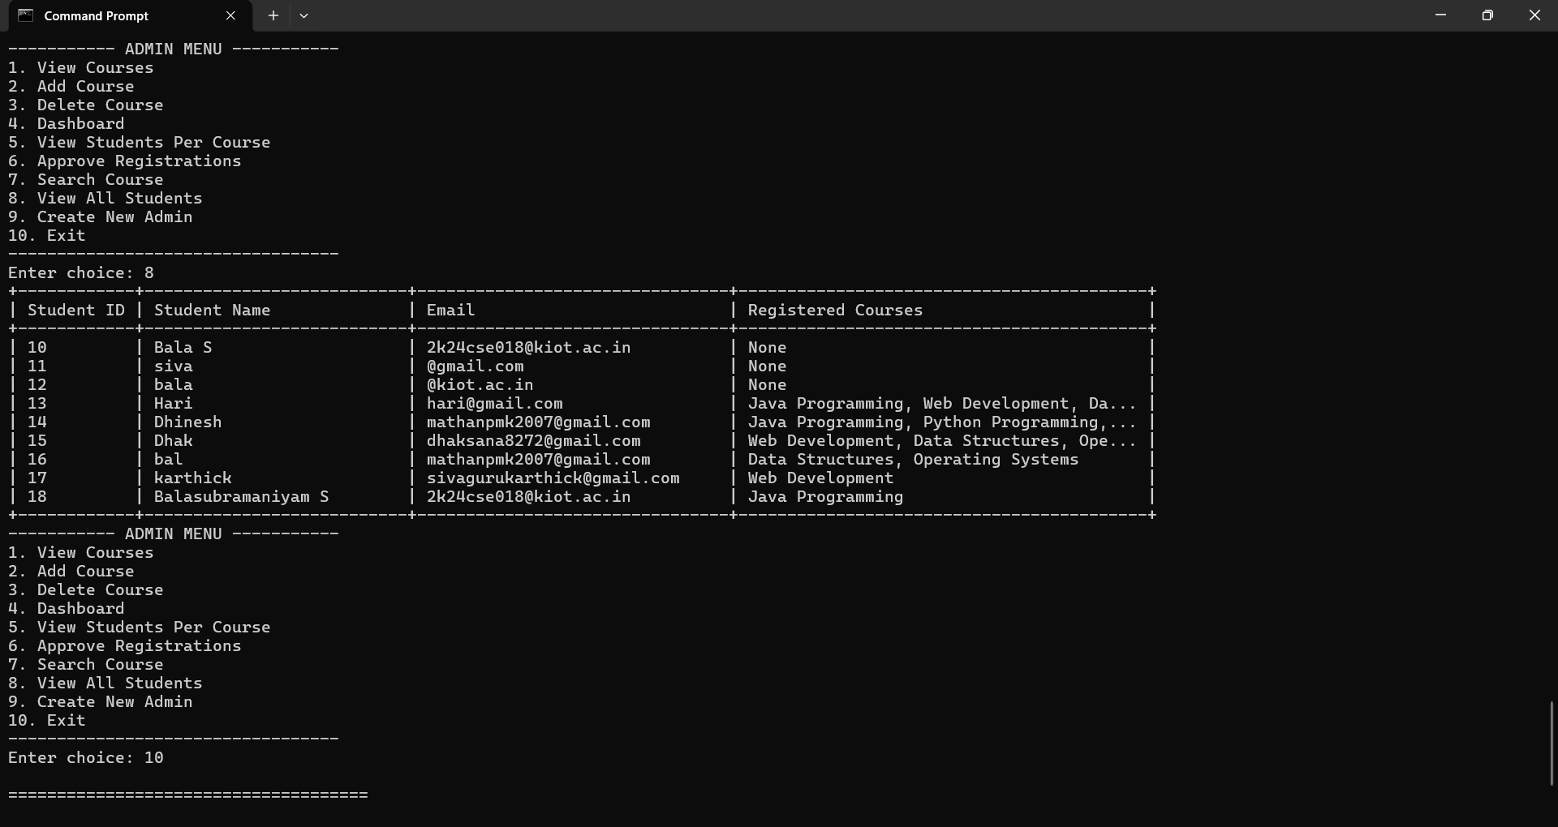
7.6 View All Students with their Details in Admin Page and Log Out

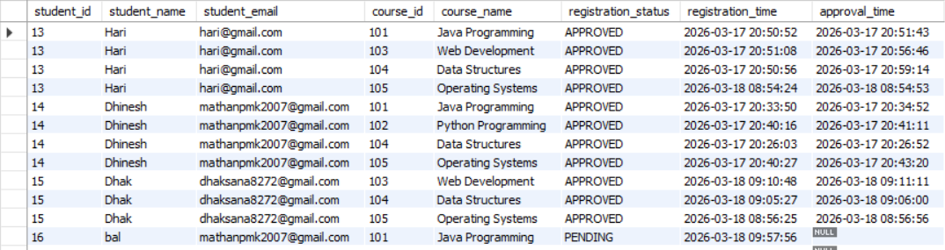
7.7 Overall Table

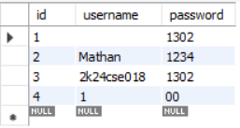
7.8 Admin Table

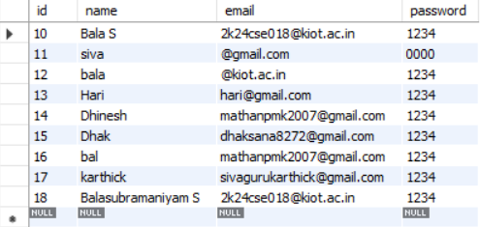
7.9 Student Table

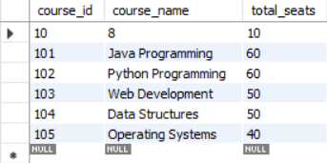
8.0 Courses Table

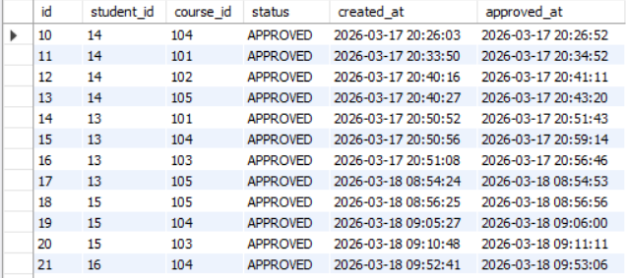
8.1 Registration Table

8. CONCLUSION
The Course Registration System is a comprehensive solution designed to automate and streamline the process of course enrollment in educational institutions. Traditionally, course registration involved manual procedures, such as filling out paper forms, submitting them to the administration, and waiting for approval, which often led to delays, errors, and difficulties in maintaining accurate records. By implementing this system, these challenges are effectively addressed, providing a faster, more reliable, and user-friendly platform for both students and administrators.
The system integrates several functional modules, including User Authentication, Course Management, Student Registration, Admin Approval, and Registration History. Each module is designed to handle specific tasks efficiently, ensuring secure login, accurate course information management, smooth registration processes, and proper tracking of registration history. Students can view available courses, submit registration requests, and monitor the status of their enrollment in real time. Administrators, on the other hand, can manage courses, review requests, and approve or reject registrations systematically.
The use of Java for application logic, JDBC for database connectivity, and MySQL for storing records ensures that the system is reliable, scalable, and capable of handling a large number of users. Additional features such as input validation, error handling, and role-based access control enhance security and maintain data integrity.
Overall, the Course Registration System not only reduces administrative workload but also improves accuracy, transparency, and efficiency in academic management. It demonstrates how modern technology can transform traditional educational processes, providing a practical and effective solution for managing course registration in institutions of any scale.

9. REFERENCES
[1] Prasad, S. Java Programming for Beginners. BPB Publications, 2020.
[2] Herbert Schildt. Java: The Complete Reference, 11th Edition, McGraw-Hill Education, 2019.
[3] MySQL Documentation – https://dev.mysql.com/doc/
[4] Oracle JDBC Documentation - https://docs.oracle.com/javase/8/docs/technotes/guides/jdbc/
[5] Pressman, R. S. Software Engineering: A Practitioner’s Approach, 9th Edition, McGraw-Hill, 2020.
[6] Date, C. J. Database Systems: A Practical Approach to Design, Implementation, and Management, 6th Edition, Pearson, 2019.
[7] TutorialsPoint. Java JDBC Tutorial – https://www.tutorialspoint.com/jdbc/index.htm
[8] W3Schools. MySQL Tutorial – https://www.w3schools.com/mysql/
[9] Sommerville, I. Software Engineering, 10th Edition, Pearson, 2015.
[10] Online resources and official documentation of Java, JDBC, and MySQL for implementation references.

